Time Series Forecasting for Hospitality Demand
Forecasting Daily Hotel Arrivals with Holt-Winters and SARIMAX in Python
Week 2 Task | Hotel Booking Demand Dataset

Prepared by: Abhishek Pal
Computer Science Engineering (Data Science), ABES Engineering College
September 2026

1. Introduction and Objectives
Hotels commit staff, inventory and pricing weeks before guests arrive, so a reliable short-term demand forecast has direct operational value. This report builds and evaluates forecasting models for daily hotel arrivals using Python (pandas, NumPy, statsmodels, matplotlib), and critically assesses how far the forecasts can be trusted.
Objective | How it is addressed
Select a hospitality time series | Section 2 - daily arrivals from the Hotel Booking Demand dataset
Prepare and validate the data | Section 3 - completeness, anomaly screening, stationarity tests
Build and justify models | Sections 4-5 - six candidate models, tuned SARIMAX
Forecast and measure accuracy | Section 6 - 56-day holdout, rolling-origin validation, MAE/RMSE/MAPE/sMAPE/MASE
Assess limitations, recommend | Sections 7-8

2. Data Selection
The series is built from the Hotel Booking Demand dataset (Antonio, Almeida & Nunes, 2019), which was also cleaned in the Week 1 report (119,390 raw bookings reduced to 87,221 after removing duplicates, invalid guest counts and ADR outliers). Real booking records were used rather than simulated data.
Property | Value
Series definition | Number of non-cancelled bookings arriving each day, City Hotel + Resort Hotel combined
Frequency | Daily
Period | 2015-07-01 to 2017-08-31
Observations | 793 days
Mean / Std / Min / Max | 79.71 / 25.62 / 13 / 154 arrivals per day

Why this series: arrivals of bookings that were not cancelled are a practical proxy for realised demand, and they drive front-desk staffing, housekeeping and breakfast planning.
Important caveat: the dataset holds booking records, not room-night occupancy or capacity, so the target is arrivals rather than an occupancy rate. Also, the Week 1 de-duplication removed about a quarter of the raw rows, so absolute counts understate true volume; forecast errors should be read relative to this series, not as real hotel totals.

3. Data Preparation
Check | Result | Action
Completeness | 793 of 793 calendar days present; 0 missing | No imputation needed
Regular frequency | Index converted to a daily DatetimeIndex with asfreq('D') | Ensures models see evenly spaced data
Value validity | Range 13 to 154; no negative or zero days | None
Anomaly screening | 61 days fall outside a 3 x IQR fence on robust STL residuals (7.7% of days) | Kept: counts are plausible and the flags mostly reflect noisy daily volume rather than errors; deleting them would understate real volatility
Stationarity (ADF) | Level p = 0.0672; first difference p < 0.001; seasonal (lag 7) difference p < 0.001 | Seasonal differencing (D=1, s=7) used in ARIMA models

The level series is only borderline non-stationary (ADF p about 0.07), and it shows a strong weekly cycle, so seasonal differencing at lag 7 is the most natural transformation.

4. Exploratory Time Series Analysis
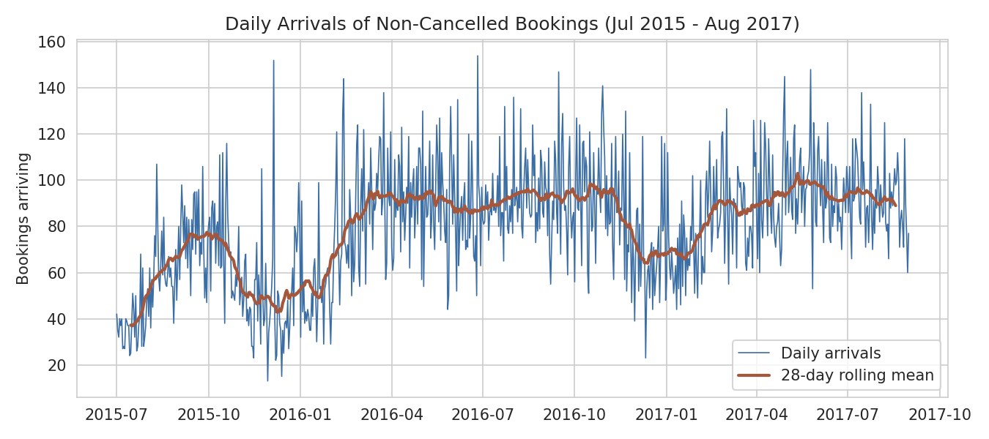
Figure 1. Daily arrivals with a 28-day rolling mean.
The series has a clear annual pattern: demand rises in spring and summer and falls in winter, with large day-to-day noise around the trend.
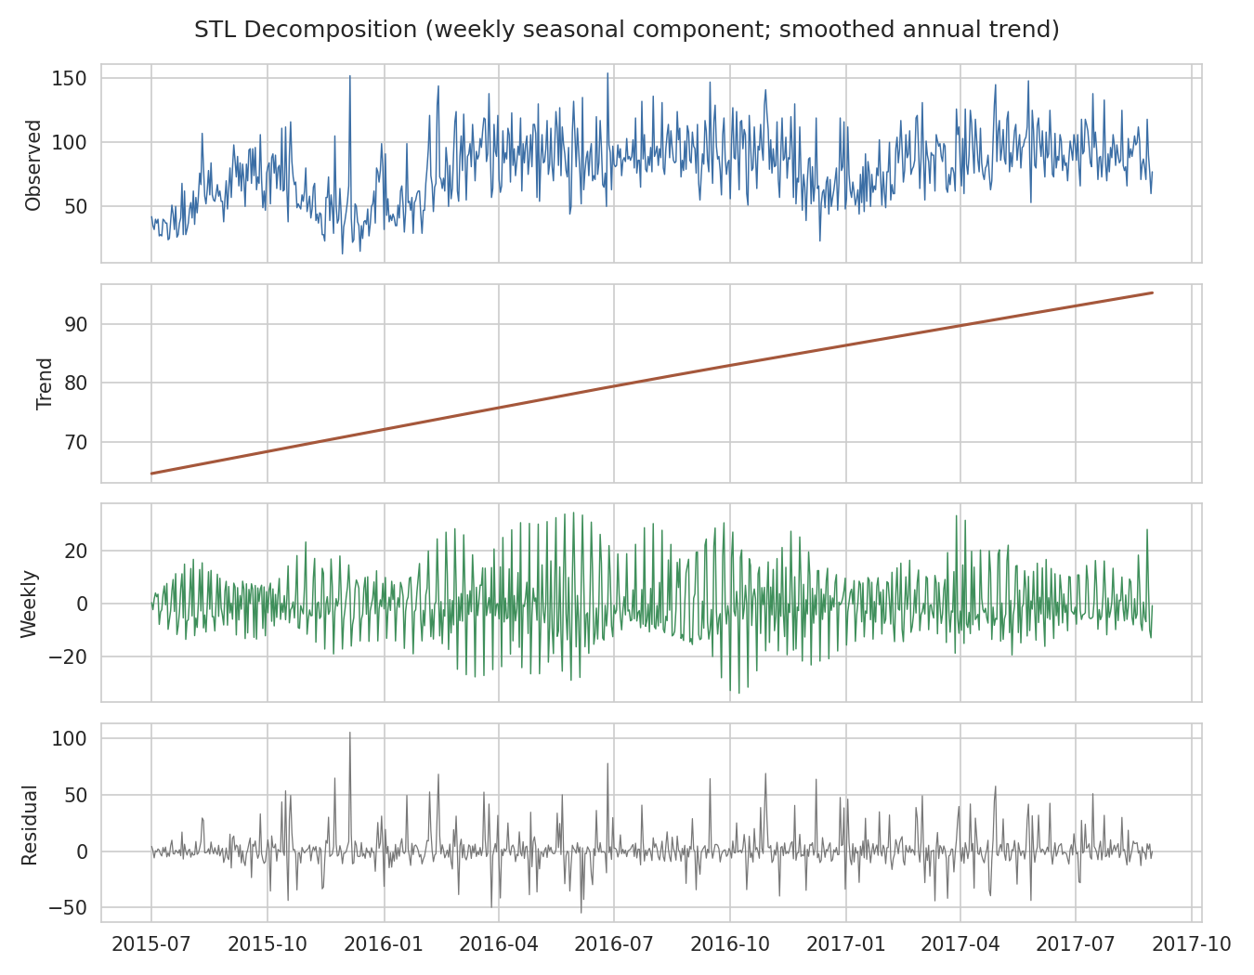
Figure 2. STL decomposition (weekly seasonal component and smoothed annual trend).
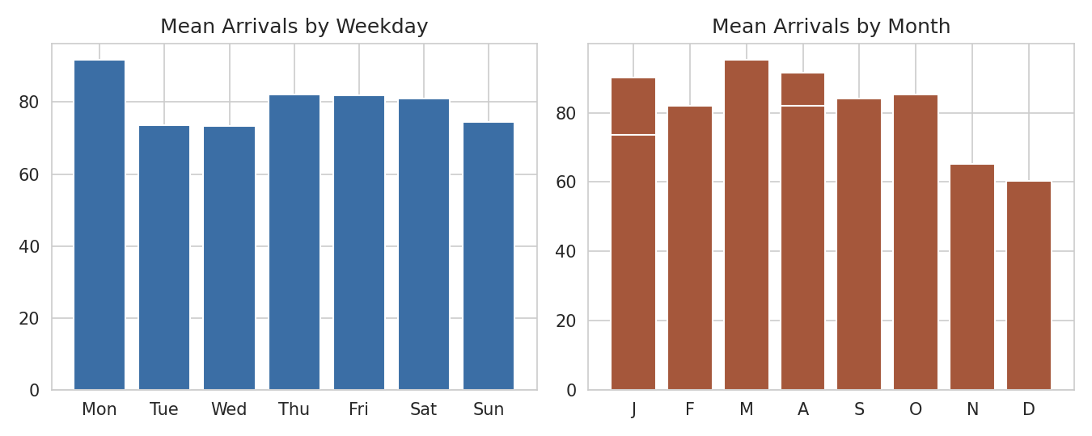
Figure 3. Mean arrivals by weekday and by month.
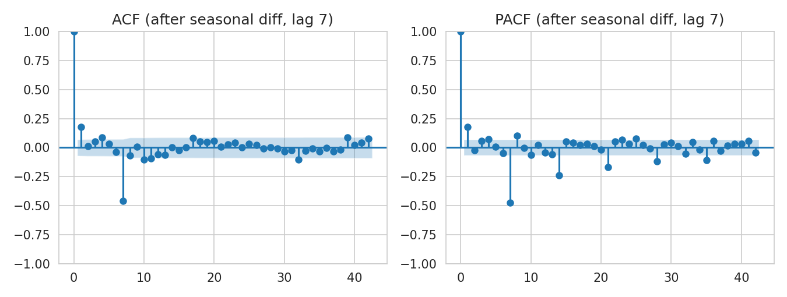
Figure 4. ACF and PACF after seasonal differencing at lag 7.
The ACF/PACF after seasonal differencing show short-lag structure plus seasonal spikes at multiples of 7, which motivates a seasonal ARIMA with both non-seasonal and seasonal MA terms.

5. Model Development and Selection

5.1 Train/test design
The last 56 days (2017-07-07 to 2017-08-31) were held out as a test set; the models were trained on the first 737 days. The test window is the peak summer period, which is a demanding test. A second check used rolling-origin validation with three 28-day folds inside the training data.

5.2 Candidate models and justification
Model | Why it was included
Seasonal Naive (7d) | Repeats the last week; the minimum benchmark any model must beat
Seasonal Average (last 4 wks) | Averages the same weekday over four weeks; a stronger, noise-resistant baseline
Holt-Winters (additive seasonality) | Exponential smoothing with level + weekly seasonality; fast and robust
Holt-Winters (damped trend) | Adds a damped trend to test whether trend helps
SARIMA(1,1,1)(1,1,1,7) | Classical Box-Jenkins model with weekly seasonality, no annual term
SARIMAX(2,0,1)(0,1,1,7) + Fourier K=3 | Adds annual seasonality through Fourier terms (a period of 7 cannot capture a 365-day cycle) and tunes the orders by AIC

5.3 Parameter tuning
For the Fourier-SARIMAX model, a grid of 36 combinations was searched on the training data: p in {0,1,2}, q in {0,1}, P in {0,1}, Q = 1, and Fourier order K in {2,3,4}, with d = 0 and D = 1 at lag 7. The model with the lowest AIC was selected.
Rank | p | q | P | Q | K | AIC
1 | 2 | 1 | 0 | 1 | 3 | 6310.3
2 | 2 | 1 | 0 | 1 | 4 | 6312.8
3 | 1 | 1 | 1 | 1 | 2 | 6321.1
4 | 1 | 1 | 1 | 1 | 3 | 6322.7
5 | 1 | 1 | 0 | 1 | 2 | 6323.1

Selected specification: SARIMAX(2,0,1)(0,1,1,7) + Fourier K=3 (AIC 6310.3). Differences between the top few candidates are small (a few AIC points), so the choice is not sharply determined by the data.

5.4 Key code
y = df[df.is_canceled == 0].groupby('arrival_date').size().asfreq('D')
train, test = y.iloc[:-56], y.iloc[-56:]

def fourier(index, K, period=365.25):
t = (index - pd.Timestamp('2015-07-01')).days.values.astype(float)
cols = {}
for k in range(1, K + 1):
cols[f's{k}'] = np.sin(2*np.pi*k*t/period)
cols[f'c{k}'] = np.cos(2*np.pi*k*t/period)
return pd.DataFrame(cols, index=index)

model = SARIMAX(train, exog=fourier(train.index, 3),
order=(2, 0, 1), seasonal_order=(0, 1, 1, 7),
enforce_stationarity=False, enforce_invertibility=False)
fit = model.fit(disp=False, maxiter=200)
fc = fit.get_forecast(56, exog=fourier(test.index, 3))
pred, interval = fc.predicted_mean, fc.conf_int(alpha=0.2)

The complete scripts are supplied alongside this report.

6. Results and Forecast Accuracy

6.1 Error metrics
Five metrics are reported: MAE and RMSE (in arrivals per day), MAPE and sMAPE (percentages), and MASE (error relative to a seasonal-naive forecast on the training data; below 1 means better than that benchmark).
Model (holdout, 56 days) | MAE | RMSE | MAPE % | sMAPE % | MASE
Seasonal Avg (last 4 wks) | 11.36 | 14.64 | 12.32 | 12.23 | 0.62
Holt-Winters (add. season) | 11.76 | 15.18 | 13.05 | 12.74 | 0.64
Holt-Winters (damped trend) | 11.76 | 15.19 | 13.04 | 12.74 | 0.64
SARIMAX + Fourier (tuned) | 12.14 | 15.51 | 13.46 | 13.06 | 0.66
SARIMA(1,1,1)(1,1,1,7) no annual | 12.35 | 15.52 | 13.92 | 13.33 | 0.68
Seasonal Naive (7d) | 16.70 | 20.61 | 18.57 | 17.73 | 0.91

Model | Rolling-origin CV MAE (3 x 28d)
SARIMAX + Fourier (tuned) | 13.30
Holt-Winters (damped trend) | 13.40
Holt-Winters (add. season) | 13.54
SARIMA(1,1,1)(1,1,1,7) no annual | 13.81
Seasonal Avg (last 4 wks) | 15.83
Seasonal Naive (7d) | 19.08

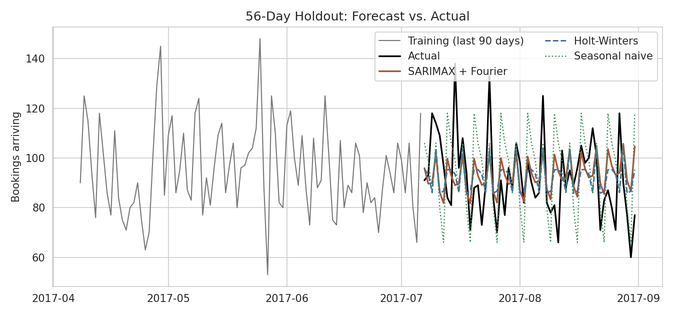
Figure 5. 56-day holdout: forecasts versus actual arrivals.
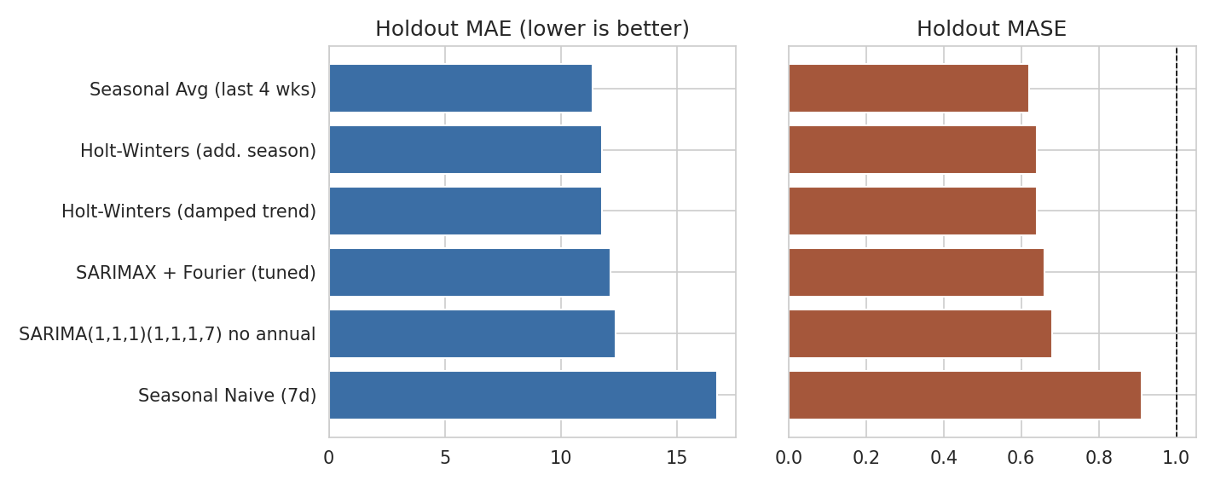
Figure 6. Holdout MAE and MASE by model.

6.2 Interpretation
- Every model beats the 7-day seasonal naive benchmark (MASE 0.91); all others reach MASE 0.62-0.68, so averaging over several weeks removes a large share of the day-to-day noise.
- On the single holdout window the simple four-week seasonal average has the lowest error (MAE 11.36), with the tuned SARIMAX at 12.14.
- Across three earlier rolling-origin folds the ranking changes: the tuned SARIMAX has the lowest MAE (13.30) and the seasonal average is much worse (15.83).
- The gaps between Holt-Winters, SARIMA and SARIMAX are under one booking per day, which is small compared with the daily noise, so these three should be regarded as roughly equivalent in accuracy.
- Adding a damped trend to Holt-Winters made no measurable difference, and the SARIMA without an annual term performed about as well as the Fourier version over this 8-week horizon.

6.3 Residual diagnostics
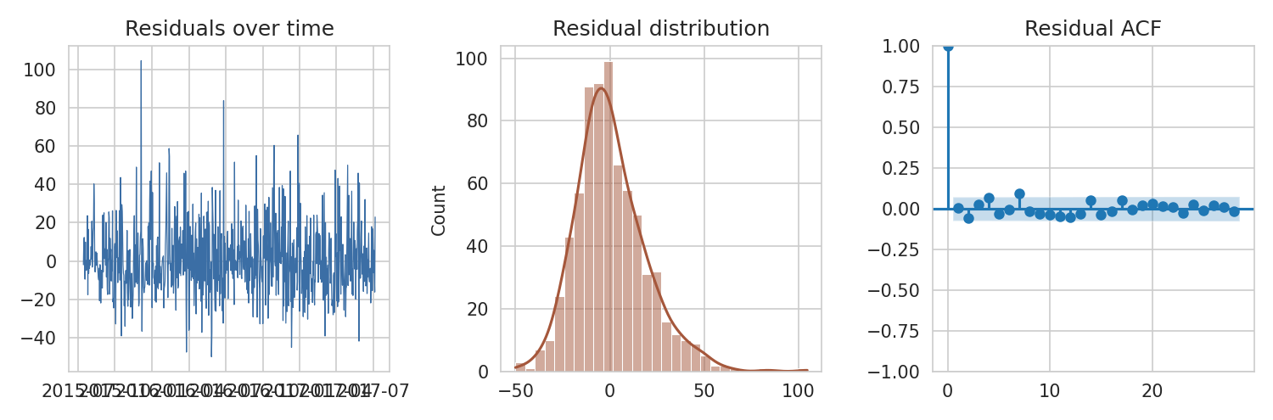
Figure 7. In-sample residuals of the tuned SARIMAX model.
Diagnostic | Result
Residual mean / std | 0.66 / 18.84
Ljung-Box p-value, lag 7 / 14 / 28 | 0.0723 / 0.1022 / 0.5176
Holdout bias (mean actual - forecast) | -1.15 arrivals per day
Empirical coverage of the 80% interval on holdout | 89.3%

No Ljung-Box p-value is below 0.05, so there is no strong evidence of leftover autocorrelation, and the bias is small. The 80% prediction interval covered 89% of holdout days, so the intervals are somewhat wider than necessary, which is the safer direction for capacity planning.

6.4 Forward forecast
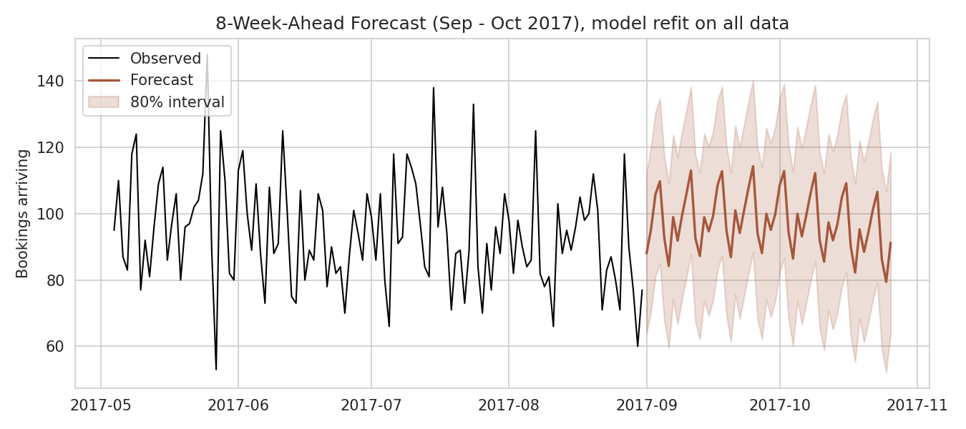
Figure 8. Eight-week-ahead forecast beyond the data, with an 80% interval.
Refitting on all 793 days, the model projects average daily arrivals of about 96.4 in the first week after the data ends, easing to about 92.5 by week eight. These values are illustrative: there is no observed data beyond August 2017 to check them against.

7. Critical Assessment and Limitations
Limitation | Effect on conclusions
Single holdout window (56 days, peak summer) | The holdout winner (seasonal average) and the cross-validation winner (SARIMAX) differ, so the ranking of close models is not reliable
Only about 2.2 years of data | The annual Fourier terms are estimated from two seasonal cycles, so annual seasonality is weakly identified; long-horizon forecasts are uncertain
High daily noise | Holdout MAPE is 12-14% for all good models; the worst single-day error was about 49 arrivals (2017-07-15), which no model anticipated
No external drivers | Holidays, events, pricing and marketing campaigns are not modelled; adding them as regressors is the obvious next step
Target is arrivals, not occupancy | Length of stay and room capacity are not modelled, so this is not an occupancy forecast
Two hotels combined, one region | Results may not transfer to other properties or markets
De-duplicated counts | Absolute volumes are understated; relative patterns should be unaffected but this was not tested

8. Recommendations
- Use the SARIMAX(2,0,1)(0,1,1,7) + Fourier K=3 model as the working forecaster: it was best in rolling-origin validation, produces prediction intervals, and extends to longer horizons through its annual terms. Keep the four-week seasonal average as a permanent benchmark, since it was hard to beat on the holdout.
- Plan around the interval rather than the point forecast: staffing for the upper end of the 80% interval on busy days and the mean on quiet days limits under-staffing risk.
- Forecast weekly totals for staffing contracts and daily values only for short-range tasks, because aggregation averages out much of the daily noise.
- Retrain regularly (for example every week) using rolling-origin validation, and monitor MAE against the benchmark so degradation is noticed early.
- Add calendar and event regressors and, with more history, evaluate Prophet or gradient-boosted models; test any new model with the same rolling-origin protocol used here.
- Improve data quality at source: record occupancy and capacity alongside bookings, and keep cancellation timestamps, so demand and net demand can be forecast separately.

9. Conclusion
This report prepared a complete 793-day hotel arrivals series, diagnosed weekly and annual seasonality, and compared six forecasting approaches under a holdout test and rolling-origin validation. A tuned SARIMAX model with Fourier annual terms and simple seasonal baselines all beat a naive benchmark by a clear margin, while differences among the stronger models were small relative to daily noise. The main lesson is methodological: on a short, noisy series, a well-chosen simple baseline is competitive, and model claims should rest on more than one evaluation window.

References
Antonio, N., de Almeida, A., & Nunes, L. (2019). Hotel booking demand datasets. Data in Brief, 22, 41-49.
Cleveland, R. B., Cleveland, W. S., McRae, J. E., & Terpenning, I. (1990). STL: A seasonal-trend decomposition procedure based on loess. Journal of Official Statistics, 6(1), 3-73.
Hyndman, R. J., & Athanasopoulos, G. (2021). Forecasting: Principles and Practice (3rd ed.). OTexts.
Hyndman, R. J., & Koehler, A. B. (2006). Another look at measures of forecast accuracy. International Journal of Forecasting, 22(4), 679-688.
Seabold, S., & Perktold, J. (2010). statsmodels: Econometric and statistical modeling with Python. Proceedings of the 9th Python in Science Conference.

